Jimmy Goad

Project 2 Reflection

Throughout project one we were tasked with performing a number of test on each section of the assignment. The contact, task, and appointment sections were all rigorously worked and testing to get to the final and completed project. The main source of testing I used for all these was JUnit testing framework downloaded and implemented through eclipse. This kind of testing can be further described as white box testing, or testing done with complete access to the application including source code and design documents. I coded each sections and then set up a number of tests as to the requirements of the projects to help ensure that everything was working to the guidelines. Some of these test took the form of parameters such as establishing character limits or ensuring that entries could not be null and setting up error messages should problems arise. Using a good number of these tests helped to ensure that each section of the project functioned as desired and that no unexpected errors were arising when it was running. I ensured my code was efficient by following as many project parameters from the rubric as possible, and I tried to increase how technically sound all my code was by going back and reworking code after receiving feedback for each section to try to make a improved final product.
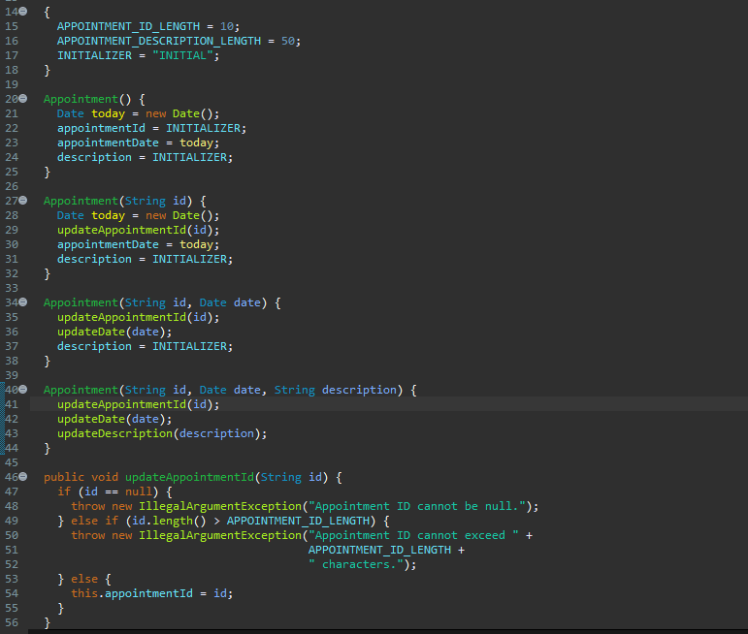
Below are some examples of the code I used to set the project tests and parameters as well as some successful JUnit tests I was able to run while making the project.

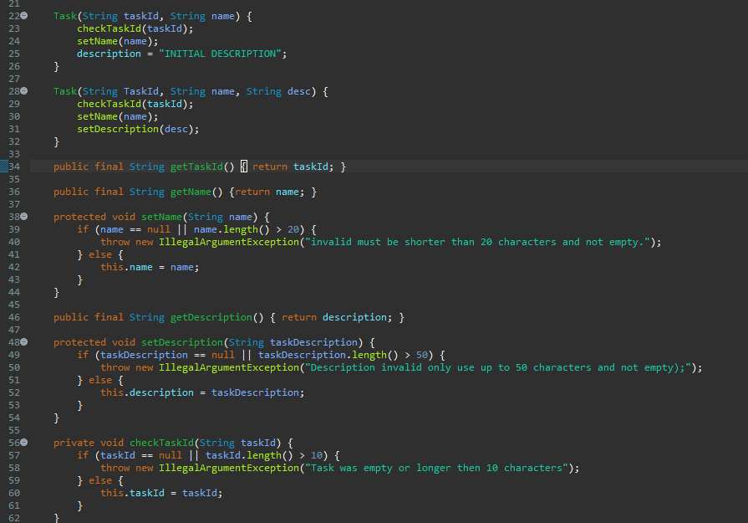

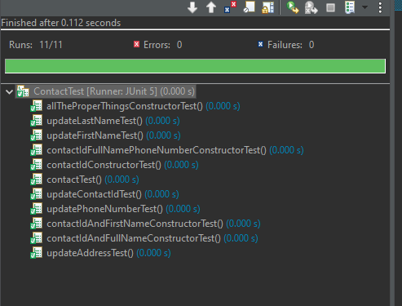

I feel I've grown as a programmer a bit as I now have a solid foundational understanding of the Junit testing system. This can be an invaluable technique in projects I have moving forward to help accuracy and functionality of my code. I did have to change my mindset from when I first started the projects to make more encompassing and effective tests and was also very cautious to start out as I was worried I wasn't connecting things currently between the test and the other code. Further along into the project I feel my comfort grew and I became a fair bit faster and competent in constructing the tests for the project. This project did help temper my discipline as well as making sure the code for each test did become a little monotonous but had to be carefully sifted through and constructed to the Junit could successfully test it and ensure it was working properly. This showed it was important not to cut corners as weak code in early parts of the projects could lead to much more complicated problems when you get to the later halves and are trying to tests the aspects of the code. I feel I combated my technical dept in this very project when I went back and restructured my contact section of my code and made it more in line with the guidelines and the project. Going back and doing a final once over and reworking anything that isn't perfect when giving the time and chance is always a great way to provide a more valuable product.

